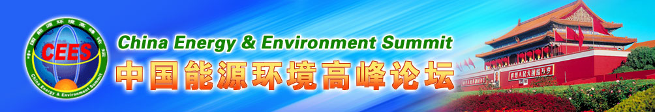
Join hands with parteners for 10 years and share CEES benefits
The 10th China Energy and Environment Summit (CEES)
Invitation Letter(First Round)

Dear Sir/Madam,
China Energy and Environment Summit (brief as CEES), jointly sponsored by National Development and Reform Commission (NDRC), National Energy Administration (NEA) , Ministry of Science and Technology( MOST), Ministry of Environmental Protection(MEP), University of International Business and Economics, China Center for Urban Development, NDRC, Center for International Economic Exchanges, NDRC，State Information Center and Xiamen University has been successfully held for 9 consecutive sessions since 2008(see Attachment 3 ). In 2009, the State Council approved the Summit as the Sub-Forum (The Largest one) of the Global Think-Tank Summit. And former Premier WEN Jiabao, Vice-Premier LI Keqiang (current Premier) of the State Council met with our honourable guests both domestic and international, and delivered speeches
In this 10th-year anniversary, CEES is honored by having had the presence of more than 1000 distinguished guests from home and abroad, which included leaders and officials from the State Council of China, CPPCC, NDRC, NEA, MEP, MOST and state-owned energy companies; the former President of India, leaders from international organizations, the Fortune Global 500 and multinationals; Nobel laureates, academicians of the Chinese Academy of Sciences, Chinese Academy of Engineering and counsellors from the State Council, and has made a lot of new achievements including a series of green/low-carbon/energy-efficient/environmental/ highly- efficient innovations, inspiring advice, classic cases and systematic theory of Green Development. All the observations and research have been included in the two blue books of CEES published by China Economic Publishing House. One is Green Development Global Dream, the other is Theory of Green Development for Ash Haze Dissipation, which have been highly regarded by People’s Daily and was translated into 8 languages by Central Compilation and Translation Bureau. Some important achievements have been adopted by the Central Committee of Communist Party of China (CCCPC)and the Central People's Government of PRC, etc. and have had a widespread effect throughout the whole society at home and abroad. CEES has been providing suggestions and advices to the authorities of energy, environment and climate change; promoting green development all across the globe and serving as the guiding and supervising principle for the green campaigns in various industries and regions, the application of green technologies; promoting international technological and economic cooperation on energy, environment and climate change.
We launched a large number of world-class innovative technologies and excellent haze-eliminating products. Many organizations with international influence have become advocators of green development and our partners, including China’s national energy and environment competent ministries. We have made leapfrog progress towards our commitment ‘more than one hundred million audiences’ by gathering tens of thousands of media and institutions to spread ideas of green development and ecological civilization construction over the past 9 years.
In order to enforce decisions and arrangements of green development and ecological civilization construction of CCCPC, The 10th CEES (2017) will be jointly hosted by China Energy and Environmental Research Center, China Center for Urban Development, NDRC. etc. It will be held in Beijing(the Great Hall of the People and/or Xiyuan Hotel) , Mid to late September, 2017. Topics and issues will include Green Development for ash haze dissipation——Green Technology, environmental protection, electricity industry deregulation, renewable energy , efficiency , low carbon , energy saving.
The Summit will invite leaders and experts from NDRC, NEA, MOST, MEP, the Board of Supervisors of Key Large State-Owned Enterprises of the State Council, Ministry of Education ; leaders from international organizations, the Fortune Global 500 and multinationals, foreign ambassadors to China; Nobel laureates, academicians of the Chinese Academy of Sciences , Chinese Academy of Engineering and counsellors from the State Council, to deliver speeches or hold group discussions.
We will consolidate the political, industrial, academic community , media and the audience at home and abroad , and high-end resources and strength of overseas Chinese we have gathered for the past 10 years. We will conduct close cooperation with other countries and international organizations, and organize sub-forums, special project pairing, the 10th anniversary serial activities, domestic and overseas investigation activities of green technology with our new and old partners. We will publish the third blue book and conduct cloud seminars and exchanges. Hundreds of central and frontline media including People’s Daily, Xinhua News Agency will cover the forum. The event will be co-hosted by Consulting Center of CEES in Beijing and other organizations which will host the sub-forum or series of activities.
1. Industry cooperation : Continue to host a series of sub-CEES on Green Technology and Environmental Governance ; Promote automobile enterprise and product propagation, cooperation on space solar energy, science, technology and education, green building cultural. The cooperation in areas such as Green energy technology and industry between China and USA, China and Europe, China and Austria will also be addressed
2. International Cooperation: set up an international electricity industry deregulation forum, which will review 20 years deregulation experiences in the world, together with 2 years of experiences in China, foster international power sector reformation, discuss the cooperation of power markets (Asia Pacific, North America, Europe and China) development, exchange experiences among nations such as U.S.A., China, Canada, Germany, France, United Kingdom, North Europe, Australia, Mexico, Philippines, Brazil, Russia, and Singapore. There will be discussions about the interactions between energy storage and power grid operations, renewable energy and green dispatch, demand side response, retail markets, and the revolution of energy industry.
3. Regional cooperation: Promote green environmental protection cooperation in Shenzhen , Guandong and some counties/cities, Fujian; Dalian cooperation in aspects of development and utilization of clean energy; regional cooperation concerning ecological civilization planning in Sichuan province.
We welcome more talents with funds, technologies, and a good knowledge of management, market and economy to join us so as to expand industrial and regional cooperation at home and abroad(see Attachment 1 ). We will systematically sum up and show the green results in the past decade and work together to push the 10th CEES to a higher level in this autumn. We will make breakthrough in key areas such as the innovation and integration of green technology, green ideas and green capital, green transformation of energy, restructuring of the electric power industry as well as the control of key issues on green development and haze eliminating. At the national and local level, we will promote the process of green economy and energy, green energy revolution, green institutional system, green culture and technology, evaluate green standards and the application of new green technology and clean the "haze" from the source in order to set out on a green path with Chinese characteristics, promote social and economic sustainable development for global well-beings.
Finally, we are looking forward to meeting you in Beijing, China.
For more details, please contact us via:
Ms. LIU Fang(CEES Vice -SG & Executive chairman of Sub-CEES), Mr. LI Yonggan
etc.( head of one Sub-CEES) , Ms. Quan Yujie, Ms.Xie, Ms.Zhang, Ms.Lian, Mr.Zhu etc.
Email: ceesint@163.com; ceeschina@139.com
Tel.：8610-56285136/64492361/68539833 Mobil: 8610-13911350670/15311983828
Fax: 8610-64492361 WeChat : CEESCEES
Websites：www.ceesint.org (English, www.ceeschina.org (Chinese)
Add: 10th Floor, Keyan Building, UIBE, No. 10, Huixin Dongjie, Chaoyang District,
Beijing; CCUD -NDRC, NO.5 East Sanlihe Rd, Xicheng District, Beijing, China
Please accept the assurances of my highest consideration.
Yours sincerely,

LIN Zhiqin

Executive Vice-president & Secretary-General of China Energy and Environment Summit (CEES), NDRC, PRC.
Director of China Energy and Environment Research Center
Prof. of University of International Business and Economics (UIBE), Beijing, PRC.
Attachment 1
The 10th China Energy and Environment Summit (CEES)
Tentative Guests List (first round)

- Part of the Chinese main guests intended to invite who joint us in this or previous years (Their names arranged according to Chinese stroke order)

WAN Gang ,Vice Chairman of the Chinese People’s Political Consultative Conference
(CPPCC) and Minister of Science and Technology
ZHU Zhiwen, Deputy Minister of Education; The Hon.Chinese Speakers of West Coast of the
Straits Summit, CEES 2011
ZHANG Xiaoying, President and chief editor, The Economic Daily
ZHANG Guobao, Member of Standing Committee of CPPCC,P.R.C.; Former Vice Chairman of
the National Development and Reform Commission (NDRC) ; Former Chairman of
National Energy Administration (NEA)
ZHANG Hongtao, Counselor of the State Council ; Chief Engineer of the Ministry of Land
and Resuorces, P.R.C
ZHANG Jing-an, Chairman of the Association of China's High-tech Industrial Development
Zone; Former Vice Minister of Science and Technology
JI Xiaonan, Chairman of the Supervisory Board of the State Council for Key Large State- Owned Enterprises
FU Chengyu , Former General Manager of China National Offshore Oil Corporation
XIE Zhenhua , Chinese minister for climate change negotiations; Deputy Director of Population
Resources and Environment Committee, the CPPCC National Committee; original deputy
director of the NDRC
WEI Jianguo , Vice chairman of China Center for International Economic Exchanges; Former
Vice Minister of Commerce Ministry
※ ※ ※ ※ ※ ※ ※ ※ ※ ※ ※ ※ ※ ※ ※ ※ ※ ※ ※ ※ ※ ※
WANG Siqiang, Director-General of Department of Energy Conservation and Technological
Equipment; National Energy Administration (NEA)
WANG Xiji , Academician of Chinese Academy of Science; a distinguished precursor of Chinese
A-bomb, H-bomb, artificial satellite; Consultant of Chinese Academy of Space Technology
WANG Dong, Director and Researcher of Environmental planning institute, the Ministry of
Environmental Protection.
WANG Xiaoming, Director and Researcher of Industry Research Department of Development
Research Center of the State Council
MAO Zengyu, Vice President of China Economic Publishing House
LU Jichuan, Prof.& Deputy Dean of the Research Institute of Chinese Academy of
Management Science
SHI Lishan , Deputy Director-general of Nuclear Power Department , Deputy Director-
general, Department of New Energy and Renewable Energy, NEA
LV Wenbin , Deputy Director-General of Department of Resource Conservation and
Environment Protection, NDRC
QIAO Runling, Vice Chairman of joint CEES, Prof. & Deputy director, China Center for
Urban Development, NDRC;
LIU Fang, Prof., Vice -SG of CEES ; Executive chairman of Sub-Forum , China Energy and Environment Summit; Vice Chairman of Beijing Yishui Environment Investment Co. Ltd.
ZHUANG Rui, Prof. and Vice-Dean of Research Institute of International Economics,
University of International Business and Economics
LI Ming , Prof. & Vice Dean of Chinese Academy of Space Technology(the fifth branch)
(WANG Li, Prof.& Deputy chief researcher, HOU Xinbin, Prof. of Qian Xuesen Laboratory
of Launch Vehicle Technology, China Academy of Space Technology, the China Aerospace
Science and Technology Corp.)
LI kai, Deputy director of the State Information Center
LI Tie , Prof. & chairman of the council, China Center for Urban Development, NDRC;
LI Jun-Feng , Director of National Center for Climate Change strategy and international
Cooperation, NDRC
LI Nuyun, Deputy director of Climate office, State Forestry Administration
HE Bingguang, Director of Major Project Inspector 's Office , NDRC; Former Director-General
Of Department of Resource Conservation and Environment Protection , NDRC
ZHANG Shouying, Prof & Director of Theory Dept., People's Daily
ZHANG Jianhua , Governor of Beijing Rural Commercial Bank, Former Director of China
People's Bank Research Bureau
ZHANG Zhenlong, Vice- SG of China Energy and Environment Summit; Professor of China
Energy and Environment Research Center
CHEN Quan-shi, Professor of Tsinghua university; Director of Electric vehicles sub-committee,
China Auto Standard Committee
LIN Guijun, Prof. & Vice President, University of International Business and Economics
XU Dingming, Counselor of the State Council ; Vice Director General of the State Energy
Advisory Board ,P.R.C
LIN Zhiqin, Director of China Energy and Environment Research Center, Executive Vice-
President & SG of China Energy and Environment Summit, Professor of University of
International Business and Economics.
LIN Yaxian, Diapatched Diretor of Central Huijin Investment LTD, Diretor of China Orient
Asset Management Co., LTD
ZHOU Xiaoxin, Academician of Chinese Academy of Sciences, Honorary President of China
Electric Power Research Institute
ZHAO Yinong, Vice- SG of China Energy and Environment Summit, Professor of China
Energy and Environment Research Center
ZHAO Zhongxiu, Director of International Institute of Low Carbon Economy; Prof. and Vice
President, University of International Business and Economics
JIA Chengzao, Academician of Chinese Academy of Sciences; former deputy President of
China National Petroleum Co.; Member of the CPPC National Committee
GAO Shixian, deputy director of Energy Research Institute of NDRC
GUO Jiaofeng, Deputy Director & Researcher, Resource and Environmental Policy Research
Institution of DRC (Development Research Center of the State Council)
SANG Baichuan, Prof. and Dean of Research Institute of International Economics, University
of International Business and Economics
HUANG Xiaozeng, deputy director of Pollution control department, the Chinese Ministry of
Environmental Protection
GE Chang-Chun, Academician of Chinese Academy of Science; Prof. of Beijing Science and
Technology University
JIANG Qingzhe, Prof. & Secretary-General of the Party Committee of UIBE; the Vice-Standing
President of China Petroleum Enterprises Association
JIANG Liping, Vice President & Senior Engineer of the State Grid Energy Research Institute
XIE Ji , Deputy Director , Department of Climate Change, NDRC, P.R.C
A Leader from Department of Electricity Power, National Energy Administration
A Leader from Bureau of Quality and Safety Supervision for Agro-products, Ministry of
Agriculture of the People’s Republic of China

- Part of the foreign main guests intended to invite who joint us in this or previous years (Their names arranged according to alphabetical order)

David Mohler , VP & Chief Technology Officer Duke Energy
Irene Giner-Reichl, Chairman of the Global Forum on Sustainable Energy; Vice-chairman of
the Global Network for Renewable Energy in 21st Century; the Austrian ambassador
plenipotentiary in People's Republic of China and Mongolia.
Feng Hsu, Chairman, SSP Committee, National Space Society; Former Sr. Staff & Technical
Manager of NASA & Lockheed Matin USA
LANG Lixin, Vice President of LEXUS China
LI Yonggan , Independent Market Monitor of Texas Electricity Market, experienced in Power
Market design, operations and monitoring
LIU Dongsheng, Energy Market Principal Analyst, ALG Energy Limited, Australia
Mark Hopkins, President of US National Space Society
Steven Chu, Nobel Prize winner in physics; the United States Former-Secretary of Energy.
S.Julio Friedmann, Carbon Management Program Leader at the US Department of Energy
S.Ming SUNG, Asia-Pacific chief Representative of Clean Air Task Force Organization
Sergio C. Trindade , A former United Nations Assistant Secretary-General for Science and
Technology; Nobel Prize Co-Laureate
ZHAI YongPing, Technical General Counsel(Energy) , Sustainable Development & Climate
Chang Department , Asian Development Bank
In areas such as international power sector reformation and electricity market development, there will be distinguished speakers from more than 300 experts and entrepreneurs, who are mainly from countries such as U.S.A. (Southwest, California, Texas, New York, New England, PJM, MISO etc), China (Guangdong, Yunnan etc), Canada, Germany, France, United Kingdom, Nord Pool, Australia, Philippines, Brazil, Russia, Singapore, and Denmark. While the following eight subjects will be discussed, more organizations and experts with new ideas and concepts are welcomed. On the basis of the following eight topics, we welcome Chinese and overseas institutions and experts with new ideas to further join the partner team（please fill in Attachment 2 Receipt form of the 2nd round VIP of the 10th CEES）:
1. The value of energy storage in power market and how will it interact friendly with power grid operations?
2. How will traditional energy and renewable compete in the same market?
3. How can market design minimize policy distortion and foster the sustained development of electricity industry?
4. Risks facing load serving entities and mitigation measures
5. Risks of power market development and mitigation measures
6. The sequence of power market development and detailed adjustment
7. The pros and cons of aggressive and progressive power market developments
8. The pros and cons of zonal markets and nodal markets

- The second round part of tentative VIP invited from the current and previous summits（List to be continued）

Attachment 2-1
The 10th (2017) China Energy and Environment Summit
CEES Guests Receipt

Name of Institution |  |  |  |  |  |  | Name of Contact Person
Mobile-Phone |  |  |  |  |  |  | Wechat  ID
Telephone |  |  | Fax |  |  |  | E-mail Address
Topics and issues of Concern
Attending Ways | 1. Cooperation: main forum ( ); sub-forum ( ); blue book ( ); other ( )  2. Speech and Communication: The Hon. speaker ( ); speaker ( ); academic  discussion and exchange of papers ( abstract of paper attached)  3. Participants or Media Reports: senior VIP ( ); VIP ( ); reporter ( )  (Multiple Choice shall be permitted)
Personal Information of Guests
Name | Position | Department |  | Mobile-  phone |  | Telephone |  | Wechat ID |  | E-mail Address
Brief Introduction of Guests | (no more than 150 words)
For more details,  please contact us via: | Ms. LIU Fang(CEES Vice -SG & Executive chairman of Sub-CEES), Mr. LI  Yonggan etc.( head of one Sub-CEES) , Ms. Quan Yujie, Ms.Xie, Ms.Zhang, Ms.Lian, Mr.Zhu etc.  Email: ceesint@163.com; ceeschina@139.com  Tel.:8610-56285136/64492361/68539833 Mobil: 8610-13911350670/15311983828 Fax: 8610-64492361 WeChat: CEESCEES  Websites：www.ceesint.org (English) , www.ceeschina.org (Chinese)  Add: 10th Floor, Keyan Building, UIBE, No. 10, Huixin Dongjie, Chaoyang  District, Beijing; CCUD/NDRC , NO.5 East Sanlihe Rd, Xicheng District,  Beijing, China
Attachment 2-2
APPLICATION FORM FOR PARTICIPATION IN THE 10th CEES
CEES Secretariat: Ms. LIU Fang, Ms.QUAN Yujie, Ms. XIE Rui
E-mail：ceesint@163.com,; ceeschina@139.com
Tel：(86-10)56285136 , 68539833, 64492361 (Fax)

Mid to late September, 2017
PLEASE TYPE OR PRINT YOUR ANSWERS IN THE SPACE PROVIDED BELOW EACH ITEM AND RETURN THIS FORM
PARTICIPANTS
Surname/First and Middle Names  (As in Passport) |  | Your Photo
Date of Birth  (dd-mmm-yyyy) |  | Sex
Nationality |  | Present Occupation
Passport Number |  | Issuing Country
Name and Address of Present Employer
Business Telephone Number |  | Mobile/Cell Number
Business Fax Number |  | E-mail Address
Contact Points
Surname |  | First and Middle Names
Name and Address of Present Employer
Business Telephone Number |  | Mobile/Cell Number
Business Fax Number |  | E-mail Address

Attachment 3
Part of photos from Previous China Energy and Environment Summit(2008-2016)
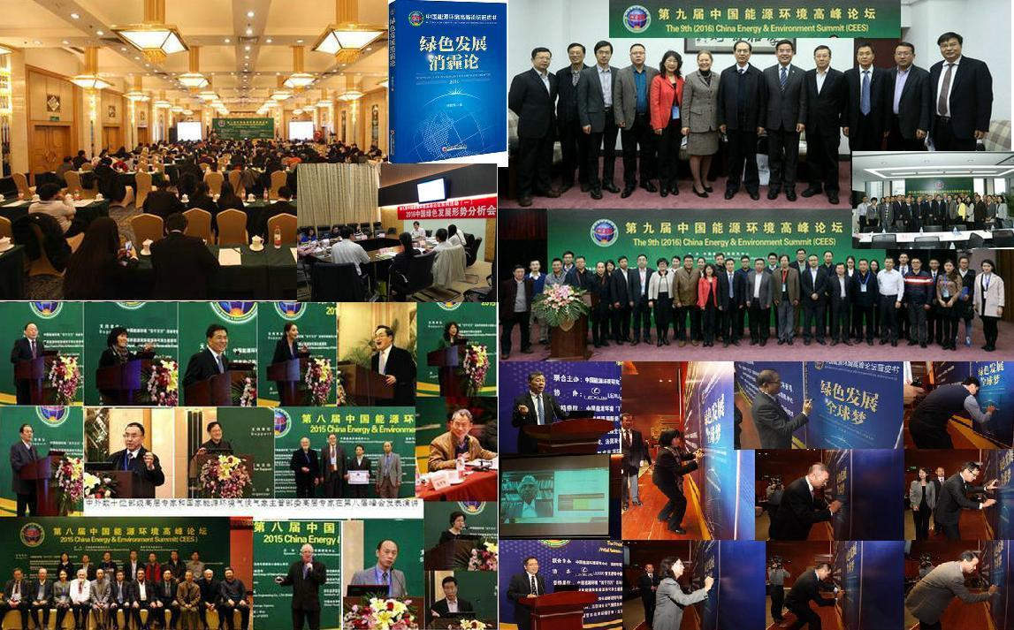
Figure 1 Part of photos of the 7th, 8th and 9th China Energy and Environment Summit and their branch summits, analysis meetings and blue books
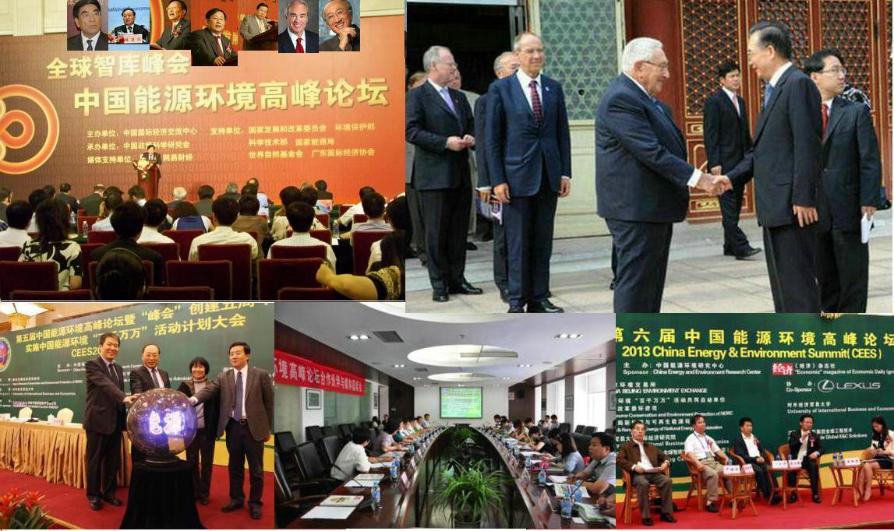
Figure 2 Part of photos of the 2nd, 5th and 6th China Energy and Environment Summit and their press conferences
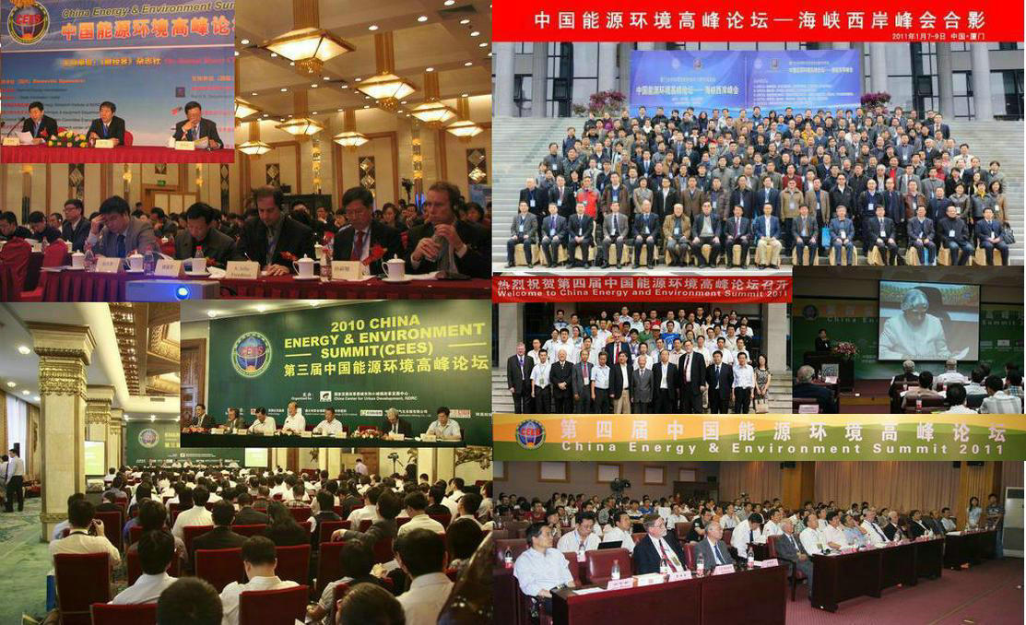
Figure 3 Part of Photos from the 1st, 3rd, and 4th CEES and the CEES West-Coast of the Straits Summit

