合作伙伴——中国空间技术研究院
及其重要演讲嘉宾选介
A brief of CAST InfoList &
Important Speakers
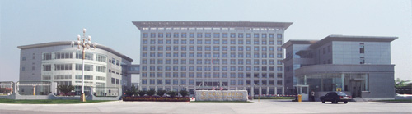
 | 中国空间技术研究院，隶属于中国航天科技集团公司，成立于1968年2月20日。经过三十多年的发展，已成为目前中国最具实力的空间技术及其产品的研制基地和中国空间事业发展的骨干力量。主要从事空间开发、航天器研制、空间领域对外技术交流与合作，卫星应用及空间技术二次开发等领域。还参与制定国家空间技术发展规划；研究、探索和开发利用外层空间的技术途径；承接用户需求的各类航天器和地面设备的研制并提供优良的服务。  1970年4月24日，中国空间技术研究院成功研制并发射了中国第一颗人造地球卫星——东方红一号，使中国成为世界上第五个自行研制和发射人造卫星的国家，开创了中国探索外层空间的新纪元。  2003年10月，神舟5号飞船载人飞行获得圆满成功，使中国成为世界上第三个能够独立开展载人航天活动的国家，树立了中国航天史上一座新的里程碑。2005年发射的神舟六号载人飞船，成功实现了多人多天的太空飞行。至2005年，研制并成功发射了68颗不同类型的人造卫星、4艘无人试验飞船和2艘载人飞船，形成了通信广播卫星、返回式遥感卫星、地球资源卫星、气象卫星、科学探测与技术试验卫星、导航定位卫星和载人航天器为主的航天器制造业务领域。所研制的各类航天器在国民经济、国防建设、文化教育和科学研究等方面得到广泛应用。航天器取得的新技术成果，移植推广到国民经济的各个部门，有力地推动了传统产业的技术改造和技术进步。  中国空间技术研究院下设10个研究所、一个工厂，建立了空间技术研制试验中心，形成了空间飞行器总体设计、分系统研制生产、总装测试、环境试验、地面设备及应用、服务保障系统等配套完整的研制生产体系。8名两院院士、12名国家级有突出贡献的专家、1700多名高级专业技术人才、以及一大批正在茁壮成长的航天新生代为中国空间事业的持续发展奠定了坚实的基础。  中国空间技术研究院先后与俄罗斯、法国、巴西、美国等十多个国家和地区的宇航公司和空间研究机构建立了广泛的联系；整星、卫星零部件出口取得突破。  展望未来，中国空间技术研究院将秉承科学发展观，与时俱进、开拓创新，发扬特别能吃苦、特别能战斗、特别能攻关、特别能奉献的载人航天精神，瞄准人类探索宇宙活动的前沿，不断开创我国航天事业的新 |  |  | 面，为建成国际一流的宇航企业而不懈奋斗。

A brief of CAST InfoList
Chinese academy of space technology, established on february 20, 1968, is a primary research center and spacecraft development base. it has twelve research institutes and one factory and has set up a complete and coordinated development and production system comprising spacecraft system design, subsystems development and production, ait, environmental test, ground equipment and its application, and service and support.
CAST successfully developed and launched china’s first artificial earth satellite dongfanghong –1 in april 1970, opening a new epoch in china’s exploration of outer space. to date the academy has successfully developed and launched 52 satellites of various kinds and four shenzhou spaceships, including scientific and technological test satellites, communications and broadcasting satellites, meteorological satellites , returnable remote sensing satellites and ocean satellite. such technologies as satellite return, multi-satellite launched on one single rocket and putting-in position of geo satellite have reached the advanced world level. we have just formed six series of satellite of remote sensing, communications, meteorological, earth resource, navigation etc, including those in high, medium and low-height orbits.
In the fields of design, development and research, cast has opened a development road with chinese characteristics for chinese space technology, realizing the development transformation from single project to multiple projects and from scientific test to series applications. the shenzhou (magic ship) spaceship has attained important achievements in scientific experiments on space science, life science and earth observation and completed the development of human spaceflight technology by leaps and bounds.
Chinese academy of space technology has established infrastructures for design, production and test of world advance level and systematic management system with quality management at the core. more than 2000 new technological results developed by cast, such as heat pipe, high resolution imager, etc., have widely been applied in a great number of economic fields, bring in with remarkable economic and social benefits.
At present, chinese academy of space technology is strengthening research and development of the follow-on tasks for human space flight as well as those of dongfanghong-4 high-capacity communications satellite, lunar exploration, and consistently opens up new areas of space activity so as to raise chinese space technology into a higher level.

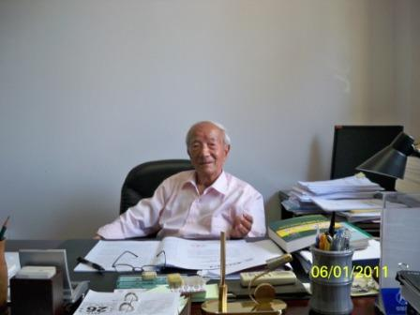
1. 王希季院士
王希季，中国科学院院士，空间技术专家，是中国空间技术的开创者之一。曾负责研制成功了中国的15种实用探空火箭，主持完成了中国第一种卫星运载火箭和第一种返回式遥感卫星的方案论证、方案设计，担任过返回式遥感卫星系列的总设计师。是中国火箭探空技术学科和航天器进入与返回技术学科的创始人之一，他提出了太空资源和航天技术体系新概念并著有《工程设计学》和《卫星设计学》，他曾作为项目的主要完成人之一获2项国家科技进步奖特等奖；获何梁何利基金科技进步奖，1999年荣获“两弹一星功勋奖章”。
Wang Xiji, Member of Chinese Academy of Science; a distinguished precursor of Chinese A-bomb, h-bomb, artificial satellite; Consultant of Chinese Academy of Space Technology
Topic: Development prediction and Countermeasures of space solar power plant technology

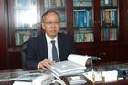
2. 闵桂荣院士
闵桂荣（1933.6-）。空间技术专家。历任中国空间技术研究院院长、卫星总设计师、国家863计划航天领域专家委员会首席科学家等职。现任中国空间技术研究院研究员、顾问。中国科学院院士。长期从事空间技术的研究和发展工作。在航天器热控制方面，负责完成了我国多种人造卫星的热控制任务，并在航天器热控制理论、方法和技术方面作出系统和创造性的成就。
Min Guirong, Member of Chinese Academy of Science, Member of Chinese Academy of Engineering, Member of International Academy of Astronautics, Consultant of Chinese Academy of Space Technology
Topic: Resources, climate and space

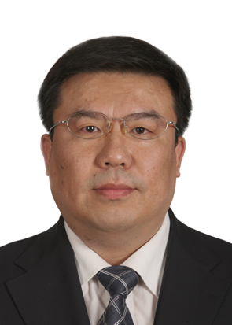
3. 李明研究员

中国空间技术研究院副院长
国际宇航联合会空间系统委员会委员
国家航天局空间碎片首席专家
国家国防科工局探月工程第三期专家组成员
科技部863计划地球观测与导航领域专家组成员
研究方向：空间飞行器总体设计
专家简介：李明研究员是中国空间技术研究院副院长、科技委主任。长期从事空间飞行器总体设计工作，曾担任卫星总师、总指挥，参加过高分辨率对地观测系统、探月三期工程等国家科技重大专项论证。现担任国家航天局空间碎片首席专家、国家863计划地球观测与导航领域专家。曾获得国家科技进步二等奖两项、国防科技进步一等奖两项。

Dr. LI Ming
- Vice President of CAST
- corresponding member of International Academy of Astronautics
- outstanding contributor for China's Lunar Exploration Program

Dr. LI Ming is Vice President of China Academy of Space Technology(CAST). He is responsible for R&D program in CAST. He attended many important space projects, including Remote Sensing Satellite-2, in which program he was Chief Engineer. He also joined feasibility studies of several National Key Program, including High Resolution Earth Observation System, Lunar Sample Returning Program and etc. He begun his study on SPS in 1992 and initiated necessity and feasibility study of SPS in China in 2006.

Dr. LI Ming is corresponding member of International Academy of Astronautics and IPC Co-Chair of International Astronautical Federation. He won twice the National Scientific and Technological Progress Prize of the second class by Ministry of Science and Technology. In 2010, he was awarded outstanding contributor for China's Lunar Exploration Program by 5 national ministries and commissions.

