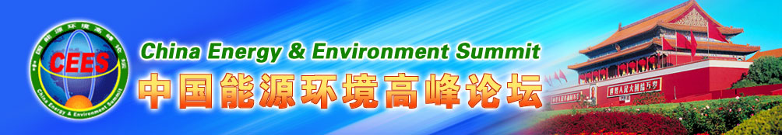

Inviting Letter from China Energy and
Environment Summit 2011(CEES)

Dear Sr. or Madam,

On behalf of Organizing Committee of China Energy and Environment Summit(CEES), I have the honor to invite you to attend CEES 2011 to be convened on Aug.28-29, 2011 in Beijing, China.

CEES, Joint sponsored by the National Development and Reform Commission, the State Energy Bureau, Ministry of Science and Technology, Ministry of Environmental Protection and Ministry of Land and Resources, has been successfully held for three sessions since 2008. Joint organized by University of International Business and Economics, China Academy of Space Technology , Space Energy Group, Department of Chemical Engineering, Tsinghua University ect. CEES 2011 will invite government officials from National Energy and Environment Administrations, domestic and international top-level experts and scholars including Buzz Aldrin, Apollo 11 moon landing astronaut, Sergio C. Trindade, Nobel Peace Prize Co-Laureate, Wang Xiji, Member of Chinese Academy of Science, a distinguished precursor of Chinese A-bomb, h-bomb, artificial satellite ect. to extend a discussion in depth on China’s high-tech and new energy ,space technology, Energy Conservation and Environment Protection and reach a consensus.

The subject of the Summit is designed in response to : (1)Strategy and planning of high-tech and new energy development, energy conservation and environment protection; (2)Development and application of high-end clean energy---Promotion and enhance of the national economy by space based solar power and development of related space technology; (3)Comparative analysis on high-tech and new energy and space technology industrialization Prospects--- solar power, space solar power, nuclear energy, bio-energy, geothermal, wind and other energy technology. (4)Green economy, energy conservation and environment protection/Financing of new energy, energy conservation and environment protection ; (5)Technology development and application study of biologic energy.

The Summit will offer Chinese and international dignitaries, top experts and scholars, business leaders to start a high-level dialogue and accelerate energy partnership between government , businesser and scholar. There will be many central media, all-round coverage and live broadcast. The attendance will be limited to invited government officials, decision-makers, global investors, senior advisors and technical/financial experts.

For more detail, please contact us by:
Phone: （86-10）68539833/57159126, 15210872703,13691301593, Fax:（8610）68539833
Email: ceeschina@yahoo.cn, cees@live.cn,
Websides: www.ceesint.org, www.ceeschina.org
I am looking forward to meeting you in Beijing.
Please accept the assurances of my highest consideration.

Yours sincerely,
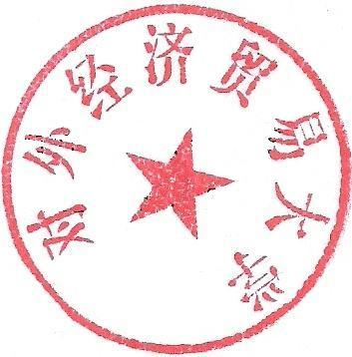
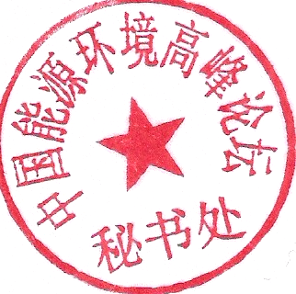
Lin Zhiqin University of International Business
Prof. & Secretariat-general, and Economics(UIBE)
Organizing Committee of China Energy No. 10, Huixin Dongjie, Chaoyang
and Environment Summit District, Beijing, China

